Network/Connection Documentation
Comtrade System Integration – AI/Robotics Team

Contents
Introduction: 3
Setup: 3
Ethernet Method: 5
WiFi Method (X2): 7
WiFi Method (A2): 7
VS Code Server: 8

Introduction:
The AgiBot X2 and A2 are both programmable machines that utilize the NVIDIA Jetson (Both use different versions of the Jetson). Both are running Ubuntu Jetpack (NVIDIA’s version of Ubuntu).
They have static IP ports that people are able to connect to via an Ethernet cable connection to a laptop. They can also be connected to via a WiFi connection, as long as both the robot and the user are on the same WiFi network and attached to the same router (to ensure this, turn on both devices or WiFi in the same room/space).
The following examples are performed in an Ubuntu (WSL2) terminal, but also work fine with a Powershell and Command Line terminal, with potentially different commands.

The X2 has two PCs that a programmer should connect to. PC2 is the general programming PC, which is where the NVIDIA Jetson Orin NX is, and where you can perform heavy computation. It also has a PC3, which holds the audio functionalities, both input and output of. The addresses of these are below separately.
The A2 only has a PC2, which is an NVIDIA Jetson Orin AGX. This one handles the secondary development, but cannot be connected to directly. The network card is on the X86 PC1, which you can then connect to PC2 from.

Setup:
Before getting into the robot, users will need to configure some settings. Plug into the robot, and open up your Ethernet settings; check which port the cable is connected to, and modify it if necessary. If it is set to Automatic, then press “Edit”, and set the below settings for the X2:

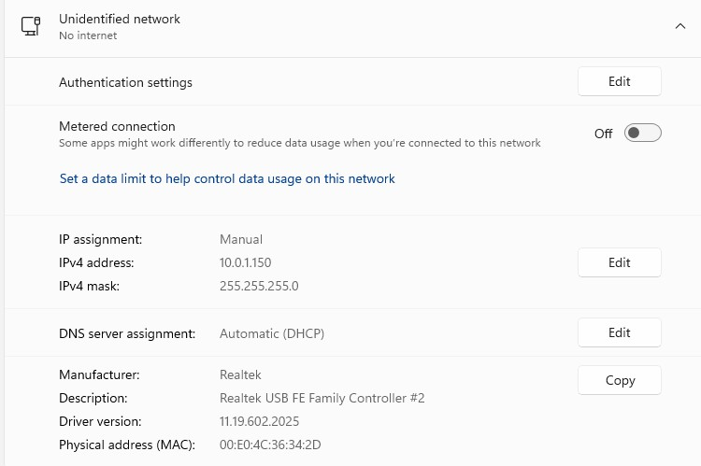

Figure 1: Ethernet Settings for the X2 setup
For the A2, it will be similar, except the IP address will be different to match the headers of the A2:
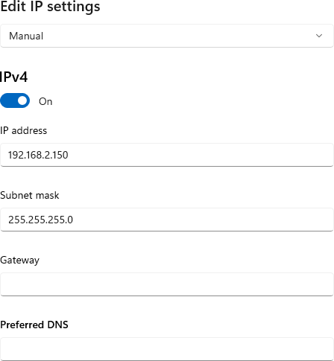

Figure 2: Ethernet Settings for A2
For both of them, you can leave the Gateway and Preferred DNS empty.

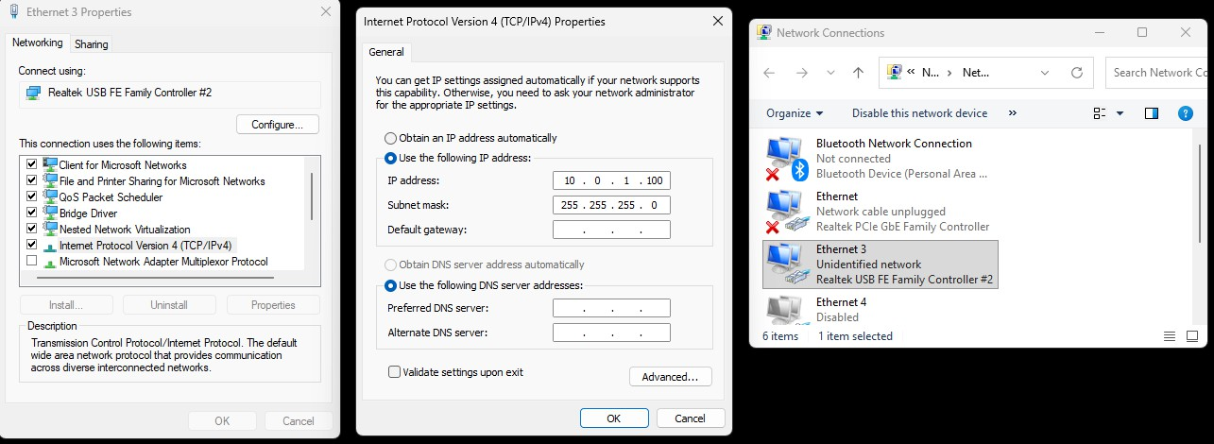
If this doesn’t work, then an alternate method is to go directly to the Network Connections app in Windows. In the search bar type “network connections”, which should show a result called “View Network Connections”. Once you click it, you will be given a small window with several options available. Press Ethernet 3 and then properties. Then, find “Internet Protocol Version 4 (TCP/IPv4)” and press it and then properties. You will open a window that will allow you to put the IP address and Subnet mask.

Figure 3: Three windows that will be opened in the process

Ethernet Method:
This is the simplest method for connecting to the X2 and A2 robots.
Simply connect an Ethernet cable to the robot via their port

IMPORTANT:
The X2’s Ethernet Port is run@10.0.1.41 (PC2) agi@10.0.1.42 (PC3) agi@10.0.1.40 (PC1)
The A2’s Ethernet Port is agi@192.168.2.50
Once the cable is plugged into your device as well (you may need an extension slot for the Ethernet cable to be inputted into your machine), open up your terminal and type the following commands:

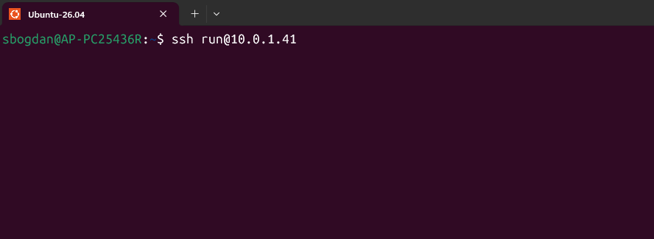

Figure 4: PC2 login for X2
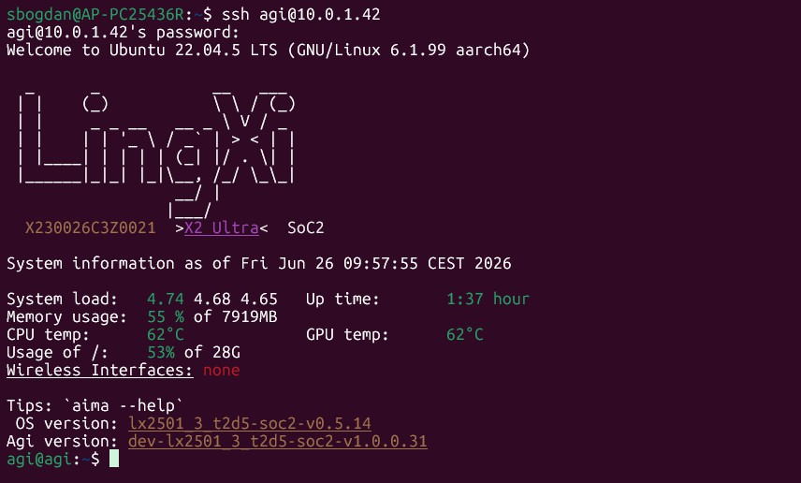
Running this successfully will prompt you for a password, as of the writing of this document, it is 1. If you cannot log in using this password, as the manager, or administrator for the robot’s password. The same scenario exists with PC3:

Figure 5: PC3 login for X2
Connecting to the A2 is the similar, except the address is different, and the robot does not have a PC3.

WiFi Method (X2):
The X2 Ultra can be connected to via Wifi. In order to do so, you need to be on the same WiFi network as the robot is. For the purposes of our work, we keep it on “Comtrade Guest”. It will have its own address for this network, which changes every day. To get the address, you will need to connect via Ethernet, at which point the system will tell you the WiFi interface
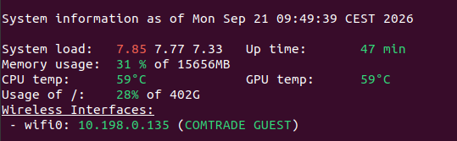

To which you can connect to.

WiFi Method (A2):
The A2 has a different connection method using WiFi. You also need to be on the same network, but the PC1 is the connection hub for the A2 instead of PC2 like in the X2. The method to do this via command line is to first connect to PC2 via Ethernet, then connect to PC1 from there. The way to do it is via
ssh agi@192.168.100.100

Which gets you into PC1. From there, you can run the following:

ip addr

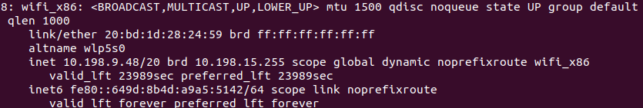

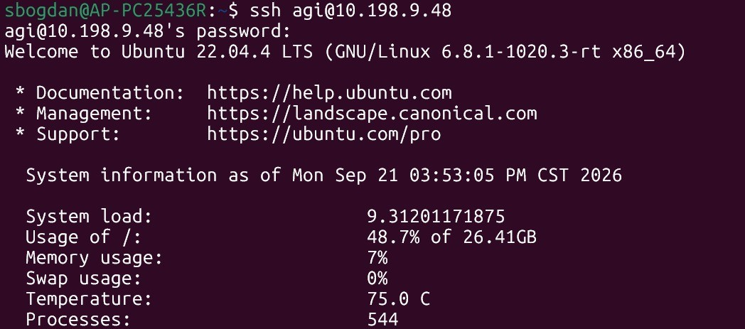
The address (in this case) is 10.198.9.48, which will allow a user to connect via:

From here, you need to get to PC2. To do this, simply run:
ssh agi@192.168.100.110
And you will enter PC2.

VS Code Server:
To use VS Code Server on the Agibots to allow for more seamless file editing and for an overall smoother coding experience (without needing to program on Vim or Nano), you can go into VS Code, and use the Remote Explorer (You will need Remote Explorer and SSH tunneling downloaded
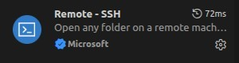

From here, you can go into the VS Code Remote Explorer Menu, and use one of the aforementioned methods to connect to the robot. For the A2, you will need to perform a jump connection, using:

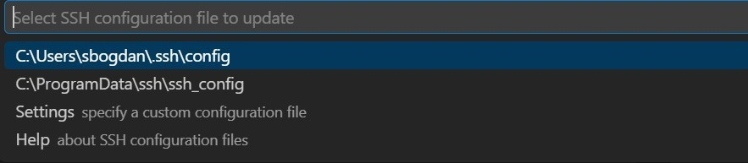
ssh -J agi@<wifi_address> agi@192.168.100.110 and press:

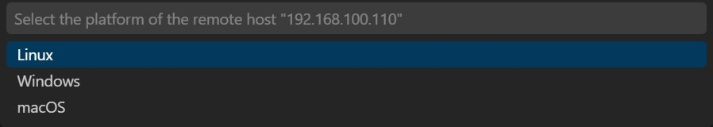
The host will be added to VS Code Server. When you click it the first time it’ll ask you a few questions. Answer with Linux and Continue for them all, and then enter the passwords for PC1 and PC2.

